Test Case: tc006_SPX_Dev5_Crear_Requisicion_Spot_Tipo_Cobro_Proyect_Urgent
Step 1 - Enter username and password and click to button Enter: Credentials Entered
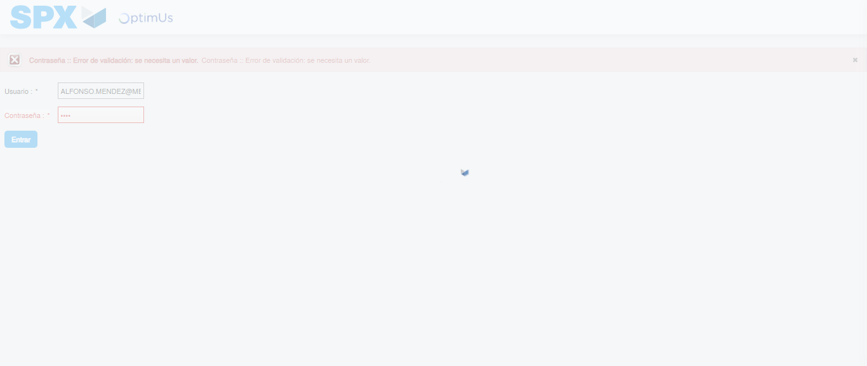Image file-name: QC_Testing-tc006_SPX_Dev5_Crear_Requisicion_Spot_Tipo_Cobro_Proyect_Urgent-1783362322207

Step 2 - Select to UEN and Access to Spot Buy Requisitions : UEN Correctly selected and Correct access
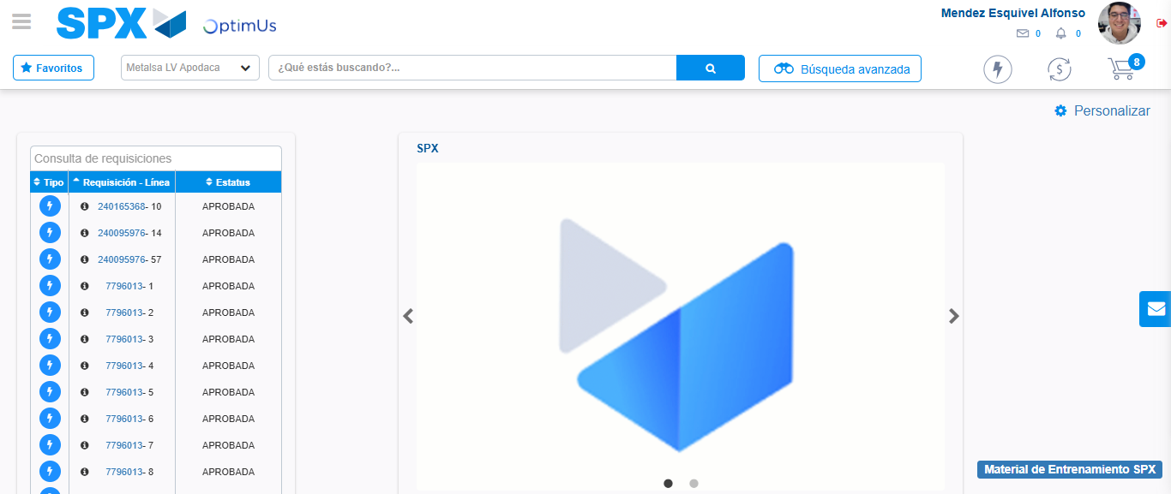Image file-name: QC_Testing-tc006_SPX_Dev5_Crear_Requisicion_Spot_Tipo_Cobro_Proyect_Urgent-1783362348480

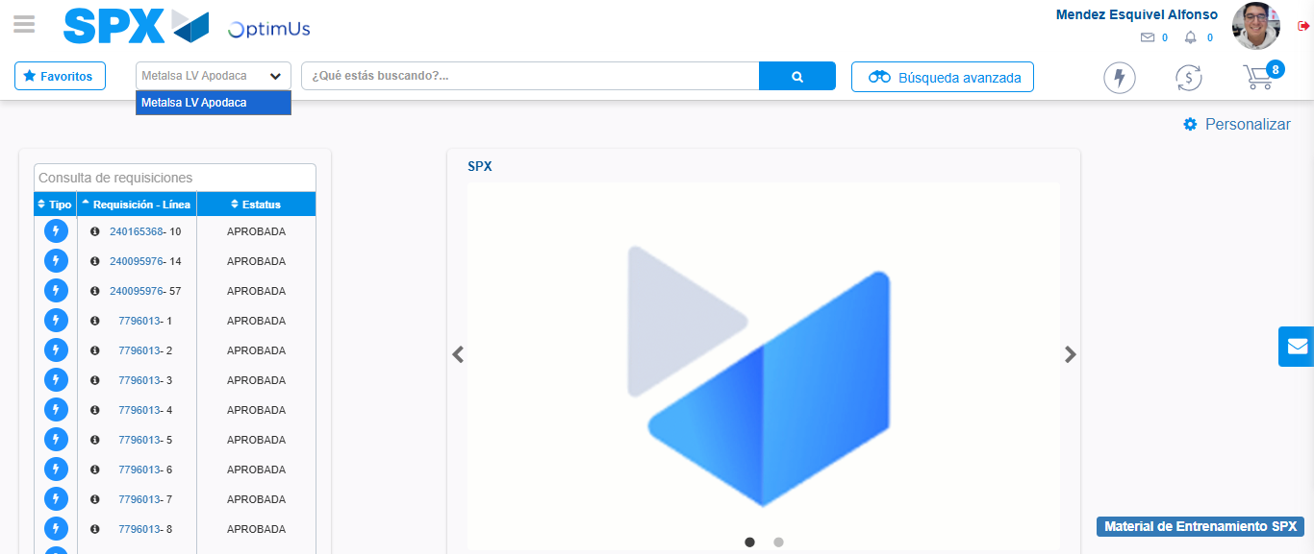Image file-name: QC_Testing-tc006_SPX_Dev5_Crear_Requisicion_Spot_Tipo_Cobro_Proyect_Urgent-1783362351182

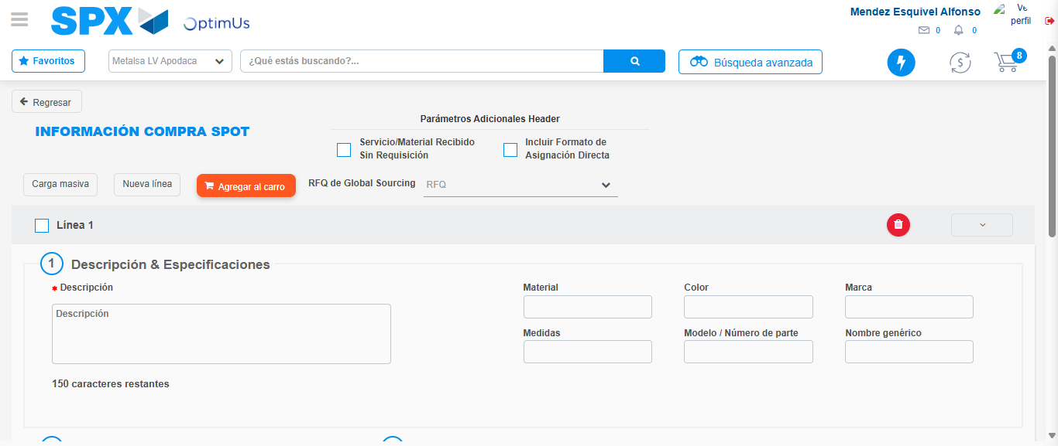Image file-name: QC_Testing-tc006_SPX_Dev5_Crear_Requisicion_Spot_Tipo_Cobro_Proyect_Urgent-1783362370703

Step 3 - Data Capture Spot Buy Requisition: Data captured correctly
Image file-name: QC_Testing-tc006_SPX_Dev5_Crear_Requisicion_Spot_Tipo_Cobro_Proyect_Urgent-1783362370987

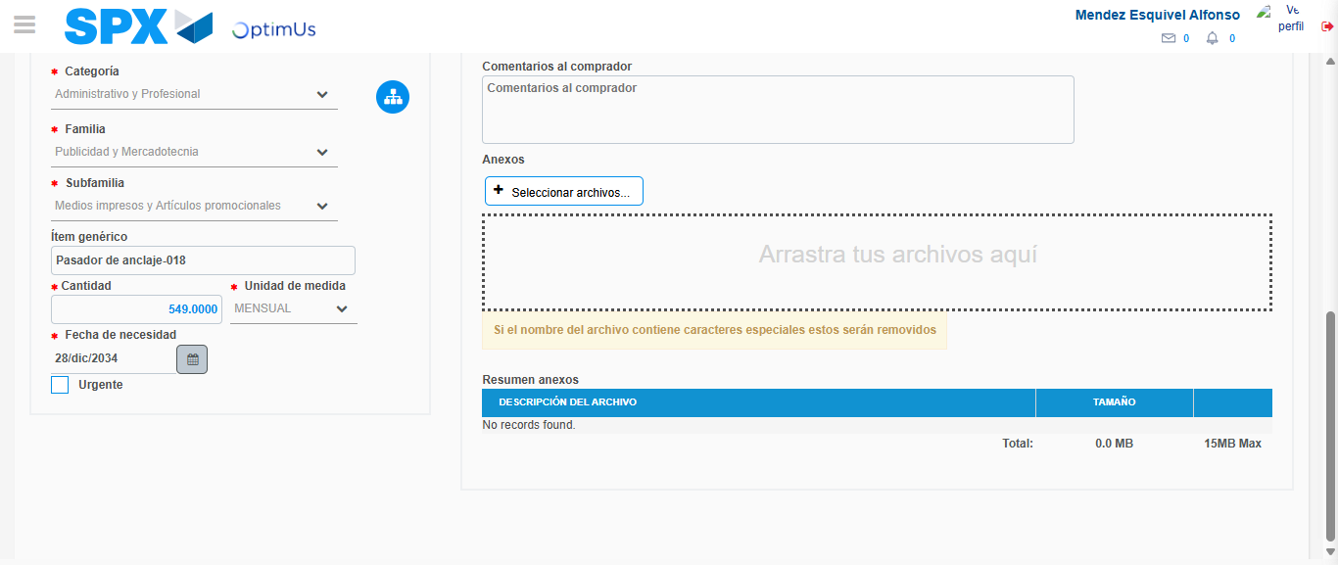Image file-name: QC_Testing-tc006_SPX_Dev5_Crear_Requisicion_Spot_Tipo_Cobro_Proyect_Urgent-1783362383817

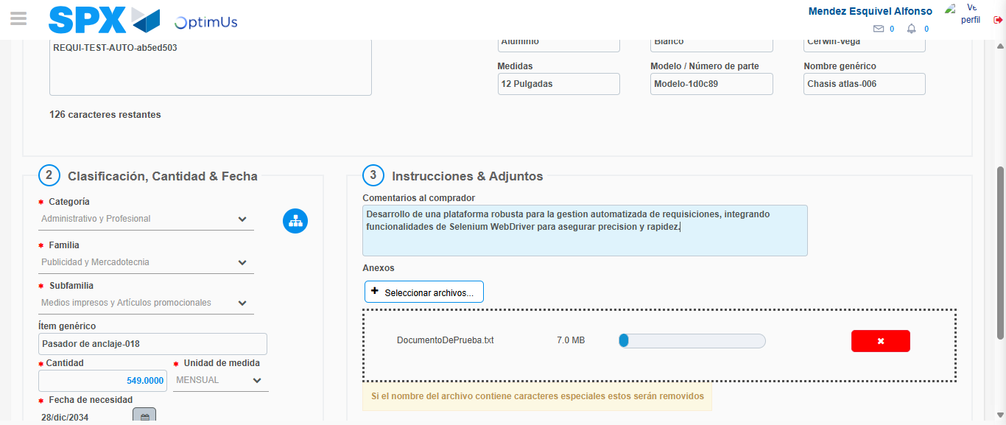Image file-name: QC_Testing-tc006_SPX_Dev5_Crear_Requisicion_Spot_Tipo_Cobro_Proyect_Urgent-1783362384767

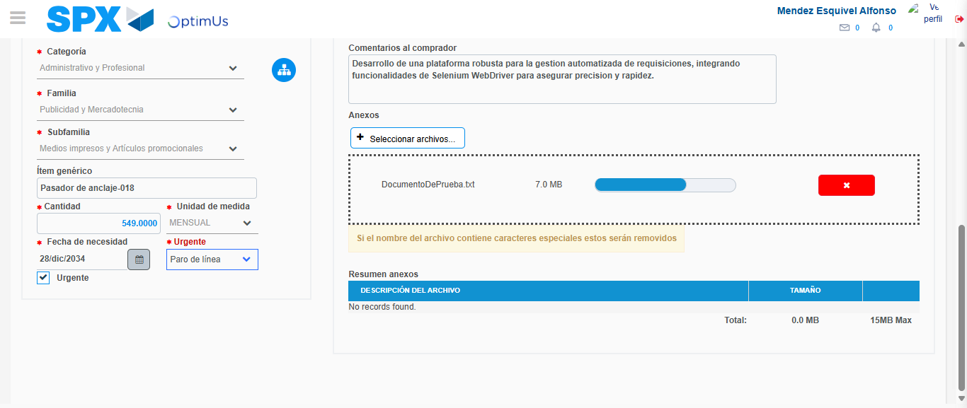Image file-name: QC_Testing-tc006_SPX_Dev5_Crear_Requisicion_Spot_Tipo_Cobro_Proyect_Urgent-1783362388703

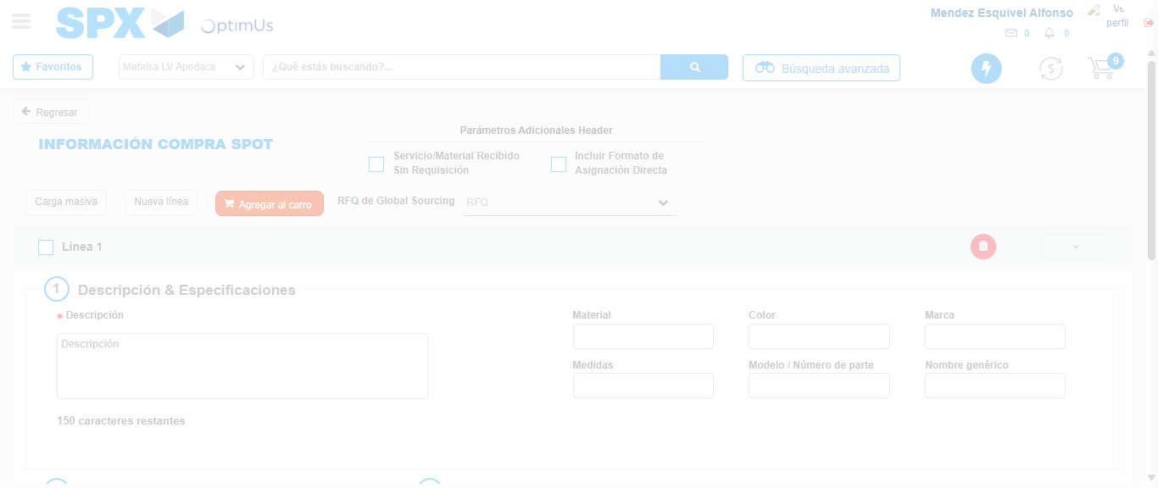Image file-name: QC_Testing-tc006_SPX_Dev5_Crear_Requisicion_Spot_Tipo_Cobro_Proyect_Urgent-1783362395629

Step 7 - Return to Main Page SPX : Return to Main Page SPX
Image file-name: QC_Testing-tc006_SPX_Dev5_Crear_Requisicion_Spot_Tipo_Cobro_Proyect_Urgent-1783362348480

Image file-name: QC_Testing-tc006_SPX_Dev5_Crear_Requisicion_Spot_Tipo_Cobro_Proyect_Urgent-1783362351182

Image file-name: QC_Testing-tc006_SPX_Dev5_Crear_Requisicion_Spot_Tipo_Cobro_Proyect_Urgent-1783362370703

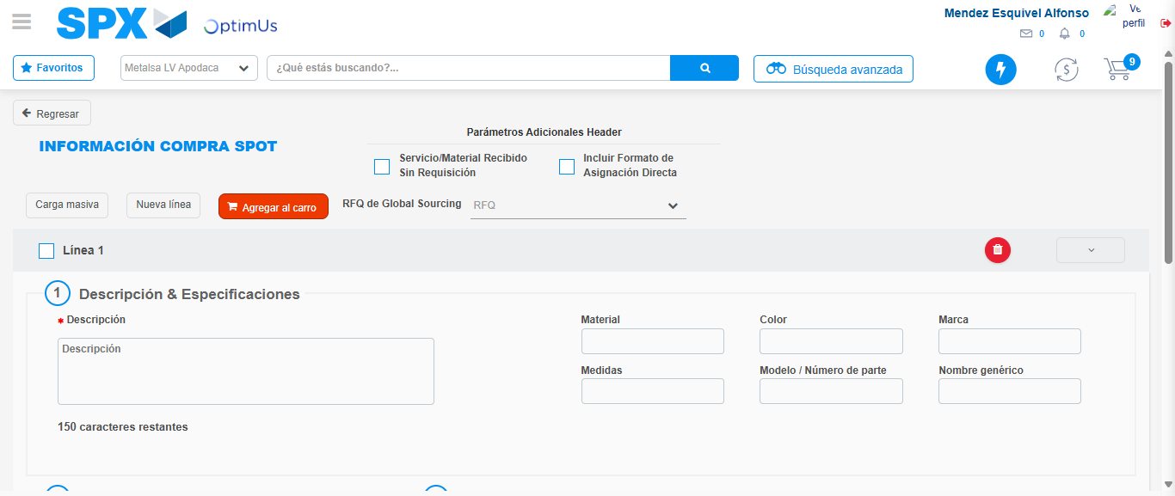Image file-name: QC_Testing-tc006_SPX_Dev5_Crear_Requisicion_Spot_Tipo_Cobro_Proyect_Urgent-1783362397929

Image file-name: QC_Testing-tc006_SPX_Dev5_Crear_Requisicion_Spot_Tipo_Cobro_Proyect_Urgent-1783362398135

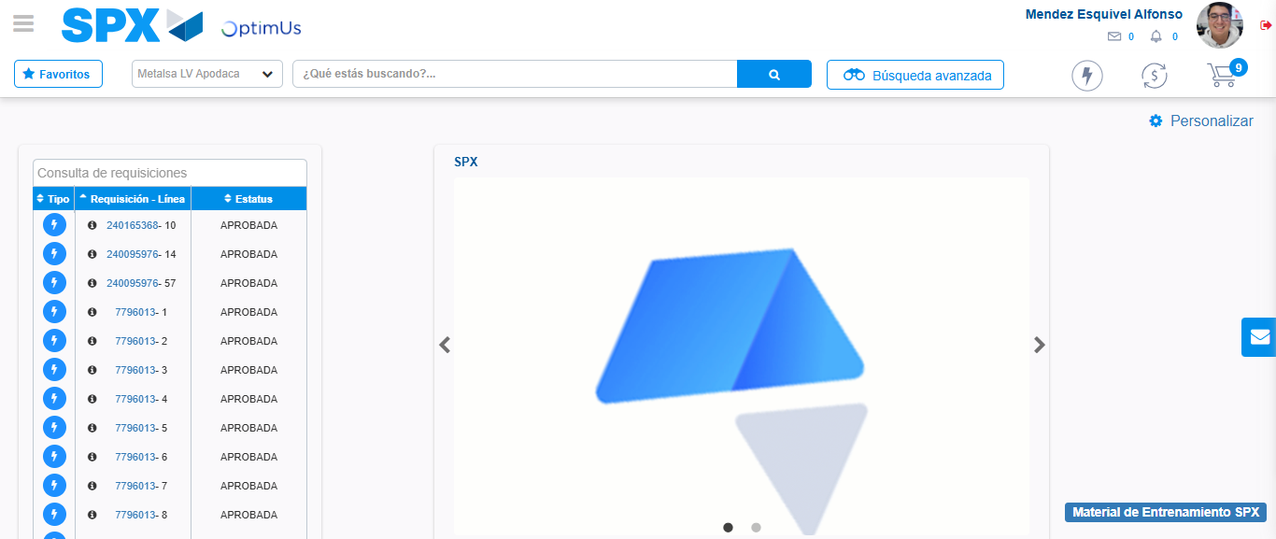Image file-name: QC_Testing-tc006_SPX_Dev5_Crear_Requisicion_Spot_Tipo_Cobro_Proyect_Urgent-1783362419476

Step 8 - Log Out : Log Out SPX
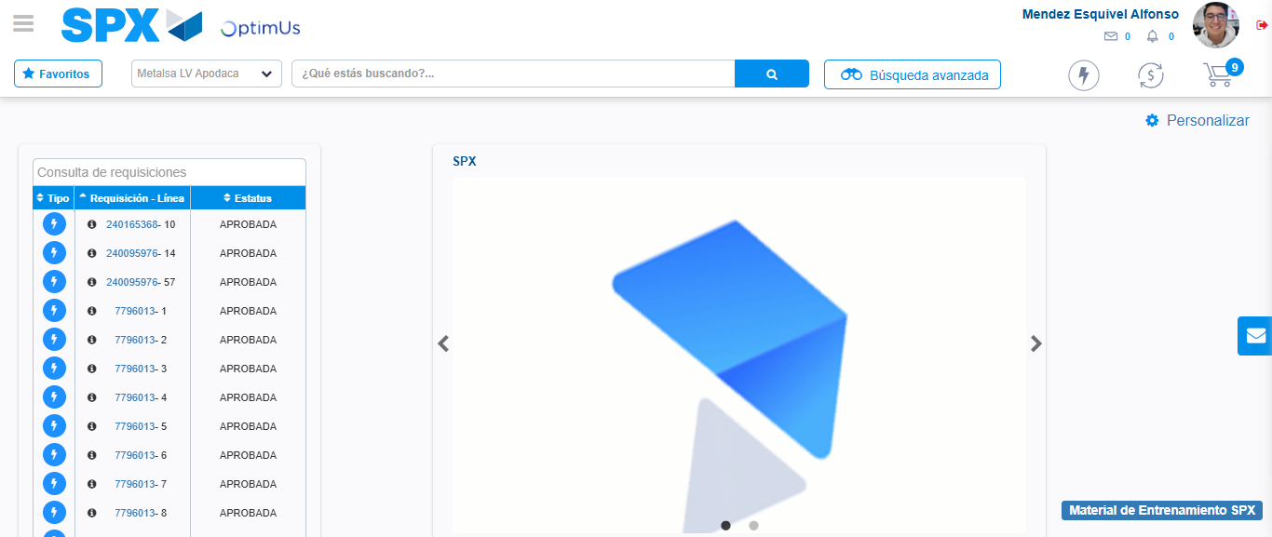Image file-name: QC_Testing-tc006_SPX_Dev5_Crear_Requisicion_Spot_Tipo_Cobro_Proyect_Urgent-1783362419712

